

MAJOR PROJECT REPORT

ON

ANALOG LAYOUT DESIGN OF

CURRENT MIRROR OTA

SUBMITTED IN PARTIAL FULFILLMENT OF THE DEGREE

OF

BACHELOR OF TECHNOLOGY

IN

ELECTRONICS AND COMMUNICATION

Under the Guidance of

Submitted By

Prof. LIPIKA GUPTA

RAJNEESH GULATI

(Assistant Dean ECE)

(1511981522)

CHITKARA UNIVERSITY

ATAL SHIKSHA KUNJ BAROTIWALA

1 | P a g e

INDEX

CONTENTS |  | PAGE NO
1. | Acknowledgment | 3
2. Abstract |  | 4
3. | Introduction | 5
 | Analog Layout Design Flow
 | Analog Layout Issue
 | Matching in Analog Layout
 | What is OTA?
4. | Procedure | 8
 | Circuit Implementation
 | Steps for Schematic Simulation
 | Result
 | Steps for Layout Design
 | Steps for Post Layout Simulation
 | Result
5. | Applications of Current Mirror OTA | 20
6. | Conclusion | 21
7. | References | 22

2 | P a g e

ACKNOWLEDGMENT

Apart from the efforts of myself, the success of any project depends largely on the encouragement and guidelines of many others. I take this opportunity to express my gratitude to the people who have been instrumental in the successful completion of this project. I would like to show my greatest appreciation to Prof. Lipika Gupta. I can’t say thank you enough for her tremendous support and help. The guidance and support received from everyone who contributed to this project, was vital for the success of the project.

3 | P a g e
ABSTRACT

The Operational Transconductance Amplifier (OTA) is the block with the highest power consumption in analog integrated circuits in many applications. Low power consumption is becoming more important in miniature devices, so it is a challenge to design a low power OTA. There is a trade-off between speed, gain and power for an OTA design since these parameters are contradicting each other. In this project, Current Mirror OTA is designed for 180nm Technology using cadence tool. This designed Current Mirror OTA achieved gain of 34 dB. The advantage of using the current mirror OTA topology is the presence of the second stage at the output end which provides a higher voltage swing and thus a higher gain. Also, the current mirror OTA has higher GBW than other topologies, so it is used in applications requiring high BW.

4 | P a g e
INTRODUCTION

Analog layout design flow:
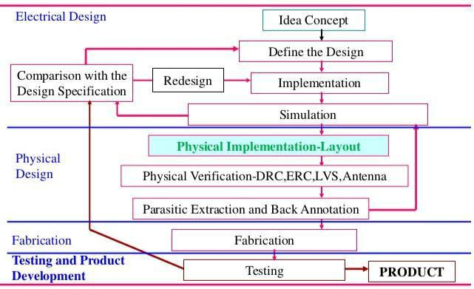

Analog Layout Issues:

Matching component

In analog electronics it is often necessary to have matched pair of devices with identical electrical properties, e.g. input transistors of a differential stage, and current mirror.

In theory two devices with the same size have the same electrical properties. Matching;

Layout technique to minimize the error introduced by process variation.

Issues that are important in digital circuit are still important in analog layout

- Minimize series resistance
  - Slows down switching speed plus introduces unwanted noise.

- Minimize parasitic capacitance
  - Shows down switching speed.
  - Increases power dissipation.

- Extra load capacitance
  - Need to increase bias current to maintain bandwidth and/or slew rate.
  - Can lead to instability in high gain feedback system.

5 | P a g e
Matching in Analog Layout:

Analog circuits often use structures like differential pairs and current mirrors, where the matching of device characteristics such as the threshold voltage Vt is important. Circuits using these structures with device threshold differences of a few millivolts or less can determine the performance and yield of a design.

However, matching also requires careful layout techniques to minimize the differences in device parameters due to distance, lithography variations, rotation, process variations, biasing, and temperature gradients on the chip.

- Common Centroid technique: In this case, two devices to be matched are split into several fingers and placed in a pattern. The key points are that the centroids of each device should coincide, the devices should be symmetrical, their orientation should be the same, and the array should be as compact as possible. Because end elements have different boundary conditions, dummy devices are often added at the ends of the rows to further reduce mismatch effects.
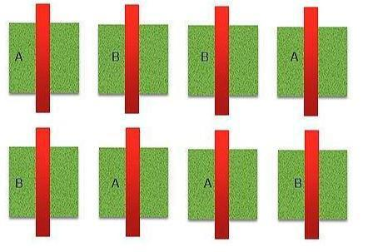

- Interdigitated Technique: In Interdigitation we take one dimensional array of transistors and is used for less no of fingers.
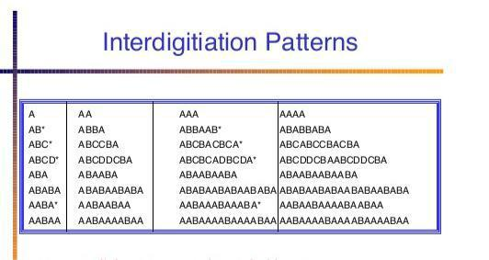

6 | P a g e
Pattern used in this project: 1) Common Centroid
D B A A A B D
D A B B B A D

What is OTA?

The OTA is basic building block usually used in designing many analog circuits such as data converters and Gm-C filters. Performance of Gm-C filters is related and based on to the OTA’s performance. The OTA is a Transconductance device where the input voltage controls the output current, it means that OTA is a voltage controlled current source device whereas the op-amps are voltage-controlled voltage source electronic devices. An OTA is basically an op-amp without output buffer, so it can only drive loads.

An operational trans-conductance amplifier (OTA) is a voltage input current output amplifier. The input voltage Vin and the output current Io are related to each other by a constant of proportionality and the constant of proportionality is the transconductance “gm” of the amplifier.

Io = gm Vin | (1)

Where, gm= Transconductance of OTA and Vin= Differential input voltage

The transconductance gm of the OTA can be obtained by varying the value of the external controlling current IC.

gm = KIC | (2)

Where K = suitable constant of proportionality

Substituting equation (1) into equation (2), we get,

Io = KVinIC | (3)

Equation (3) depicts that output current is proportional to the product of Vin and IC. In general OTA consists of a differential transistor pair with a current mirror circuit acting as a load. As OTA operates on the principal of processing current rather than voltage, it is an inherently robust device. As gm can be controlled by changing the control current Ic, the OTAs are suitable for electronically programmable functions.

7 | P a g e
PROCEDURE

Circuit Diagram for Current Mirror OTA:

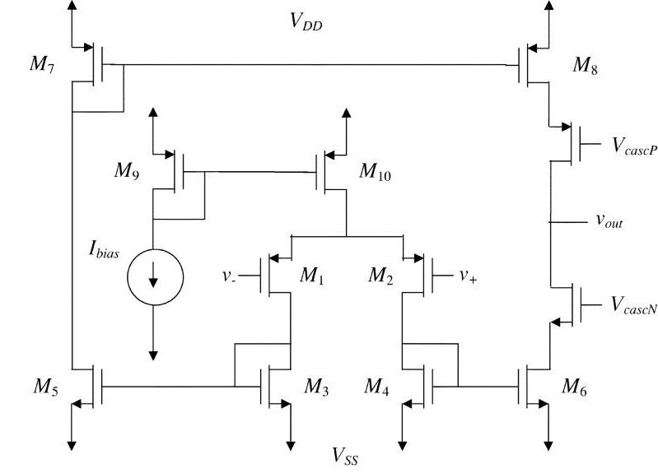

Schematic Implementation of Current Mirror OTA on Cadence Virtuoso using following W/L ratio: (n/µ)

TRANSISTORS | W/L RATIO(ꞑ /µ) | MULTIPLIERS
M1,M2 | 4.07 | 5
M3,M4 | 2.5 | 1
M5,M6 | 2.5 | 1
M7,M8 | 4.1 | 1
M9,M10 | 8.8 | 1

Idc = 74nAmp

Capacitor Value = 50pF

Vdc = +1.8V, -1.8V

8 | P a g e
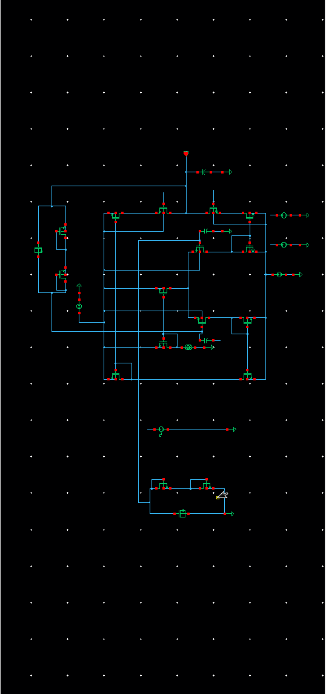

Steps for Schematic Simulation:

  - Open the terminal and make the schematic as shown in fig above.

  - Check and save the schematic and then go to "Launch" and click on "ADE L" for simulation.

- After ADE L window is opened, do transit, AC and DC analysis and obtain the waveform for them respectively.

- Then close the waveform window. Go to Results-Direct Plot-Gain VS Phase option. Select Vout and Vin pins from schematic and again obtain graph for Gain VS Phase.

- Note down the results from the graph obtain.

Result: The gain after simulation comes out to be 34 dB.

9 | P a g e
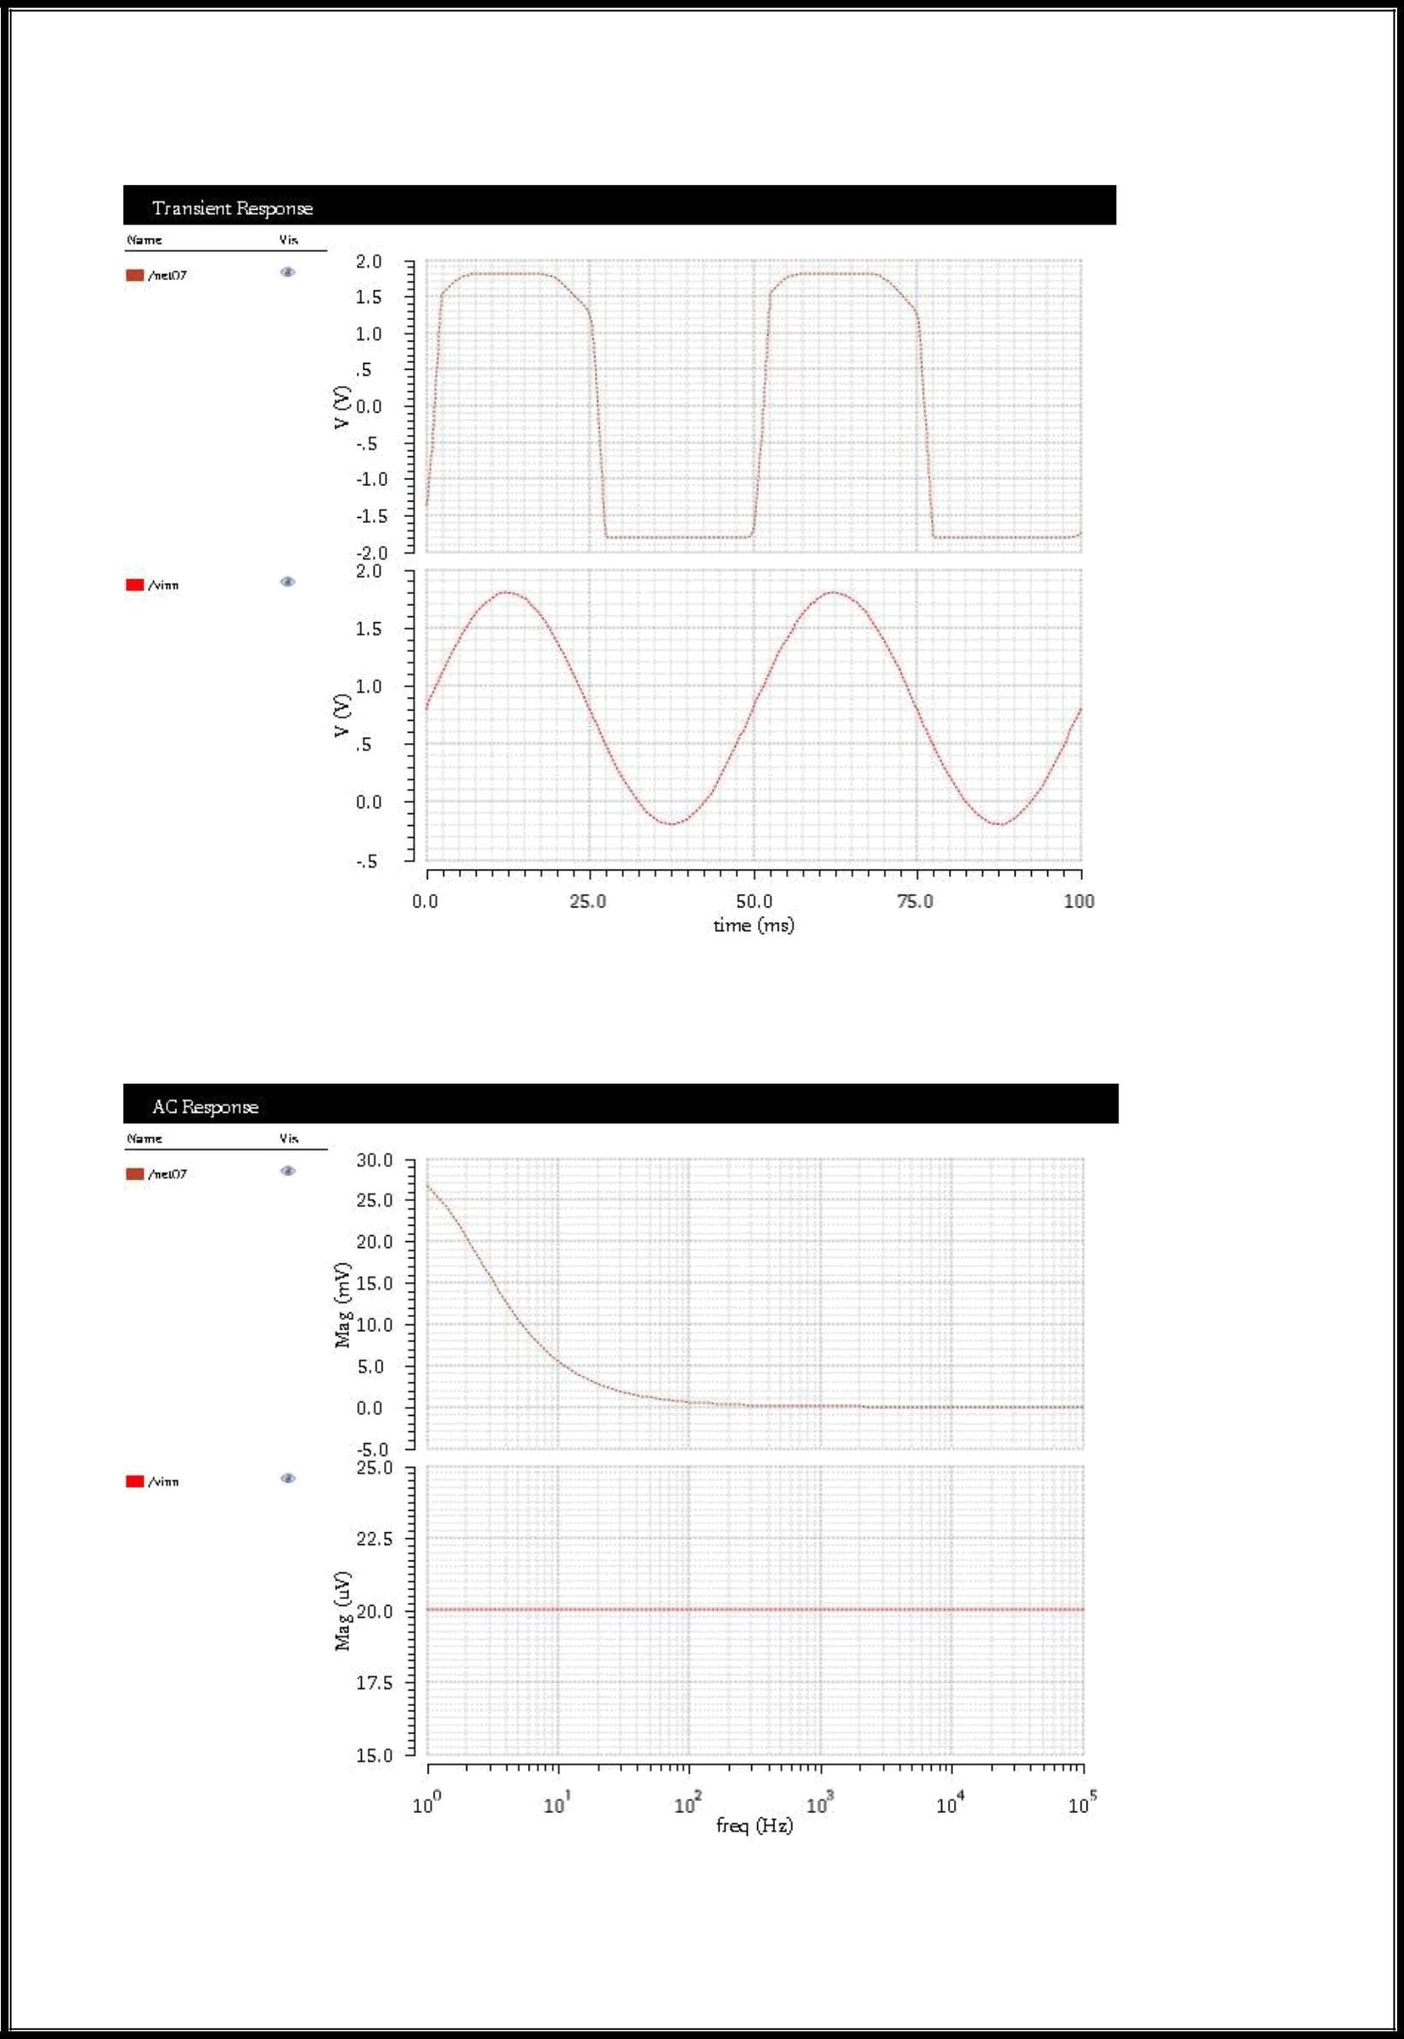

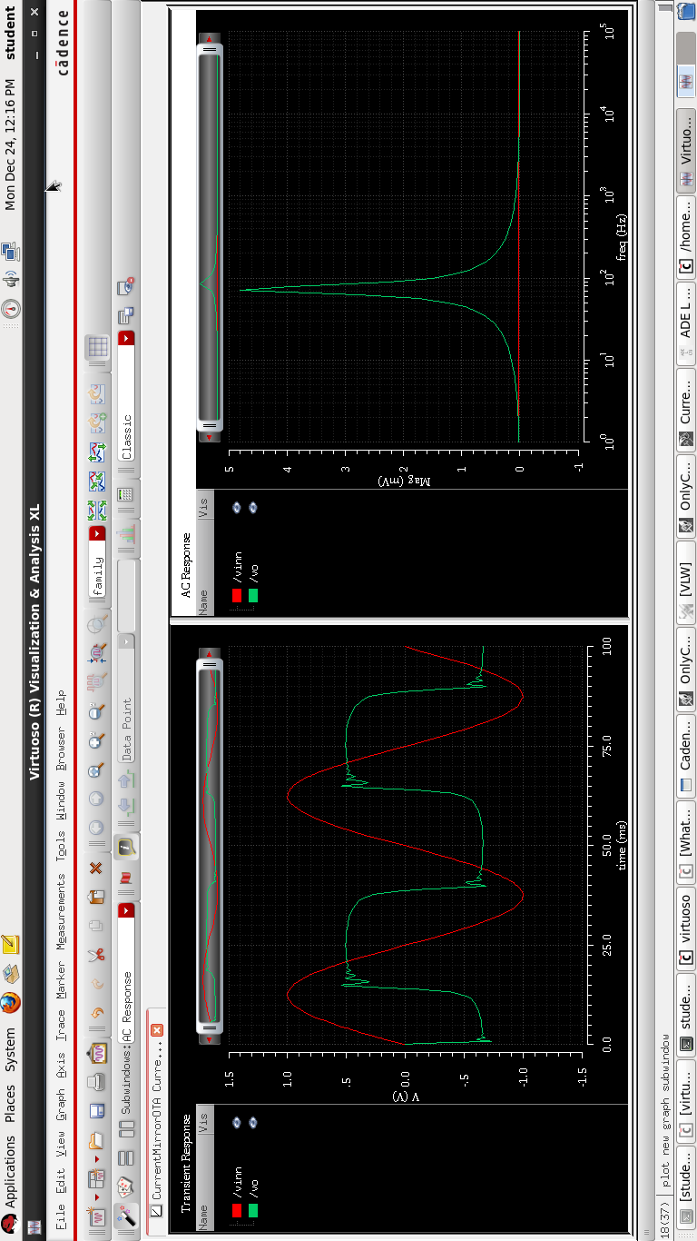

10 | P a g e
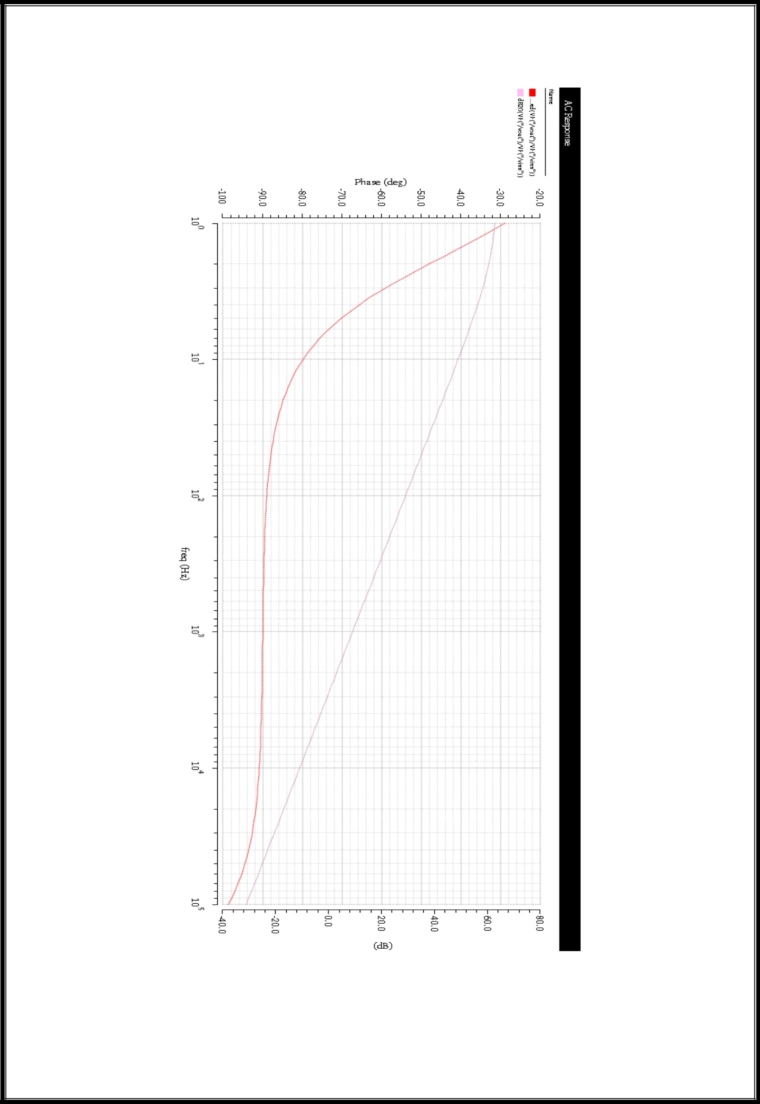

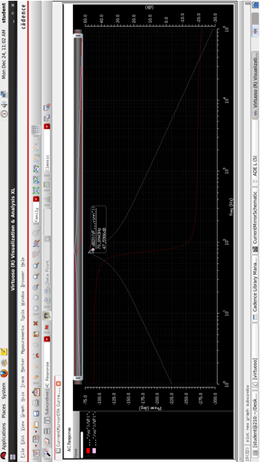

11 | P a g e
Steps for Layout Design:

- Check and save the schematic and then go to "Launch" and click on "Layout XL".

- After "Layout XL" window is opened, go to "Connectivity" and click on "generate from all sources" option.

- Now all the transistors and pins will be visible on the layout window. To make

internal layer and structure visible just press "shift+f".

- Start placing the pins and transistors and make layout matching using different matching techniques and use multiple metal layers, via and contacts where ever required to do routing.

MATCHING PATTERNS: 1) Common Centroid

D B A A A B D

D A B B B A D

- To create Vdd, go to "Create" on the taskbar, select via and select n-well from there. Similarly create gnd select p-well.

- After making layout go to "Assura" and run "DRC".

- If DRC shows errors first correct them and again run it till it shows " No DRC".

- Then again go to "Assura" and run "LVS". If it shows your all cells are matched between layout and schematic then your layout is correct. If it shows cells are mismatched, check the connections between layout and schematic, correct them and again run "LVS".

- After this again go to “Assura” and run “RCX” for parasitic extraction to carry out

post layout simulation.

12| P a g e
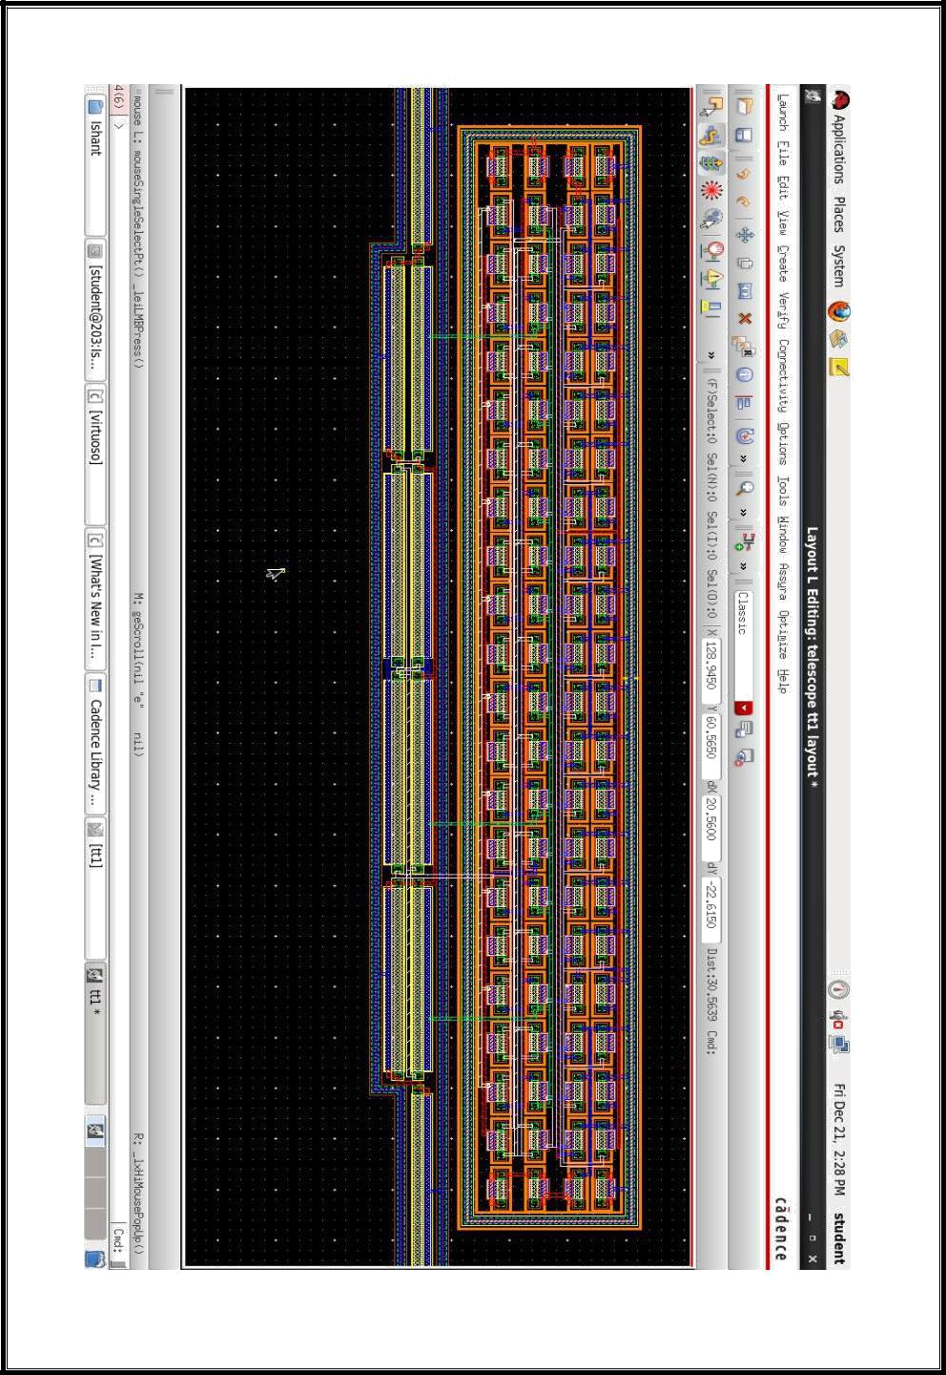
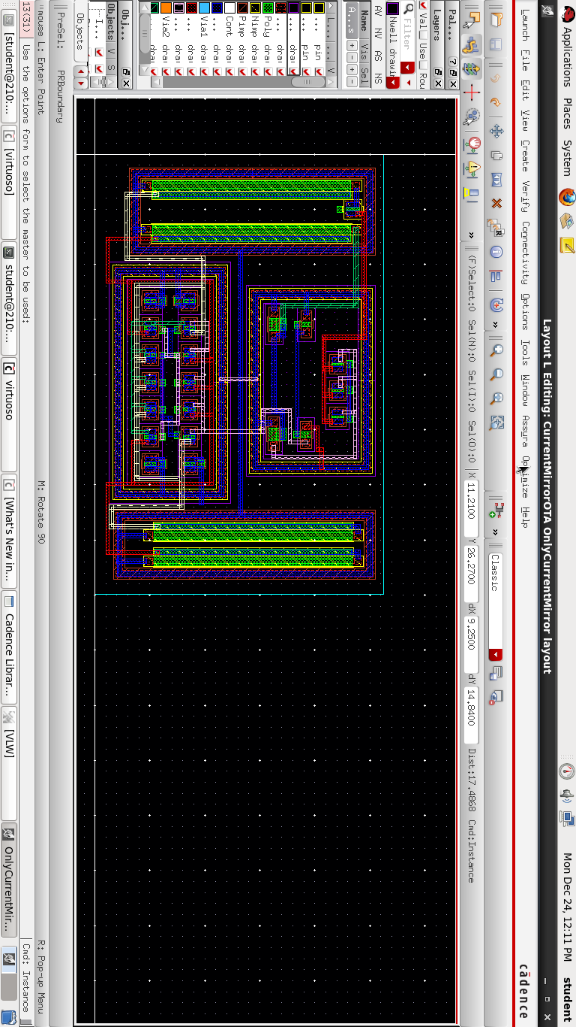

13 | P a g e
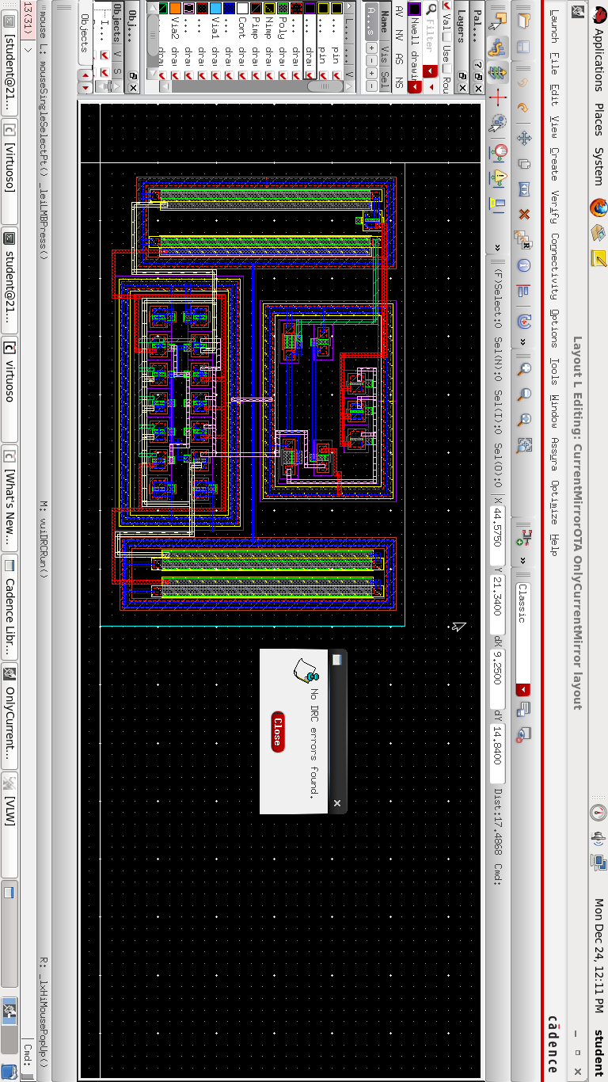
.

14 | P a g e
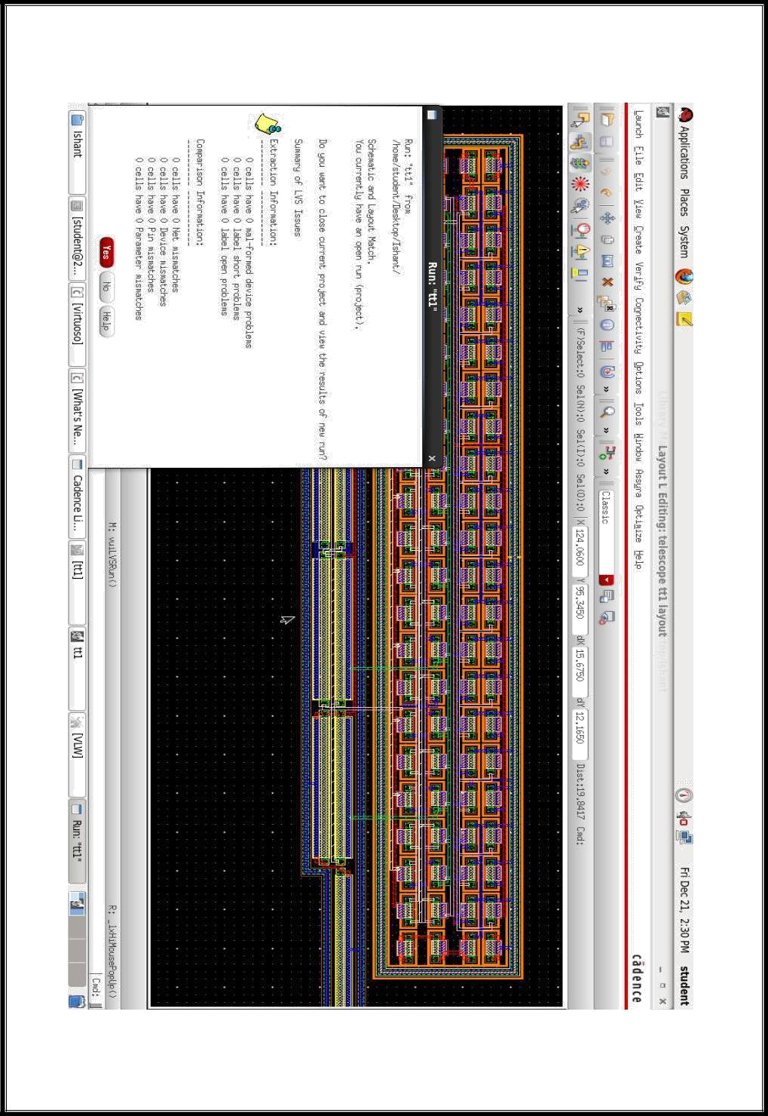

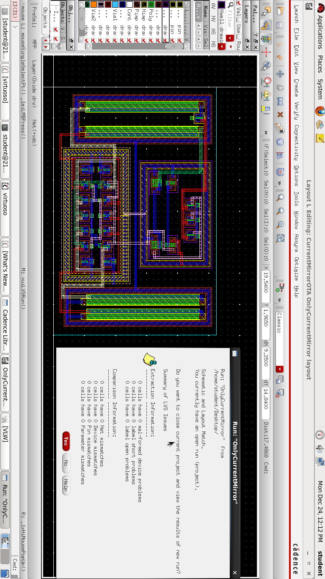

15 | P a g e
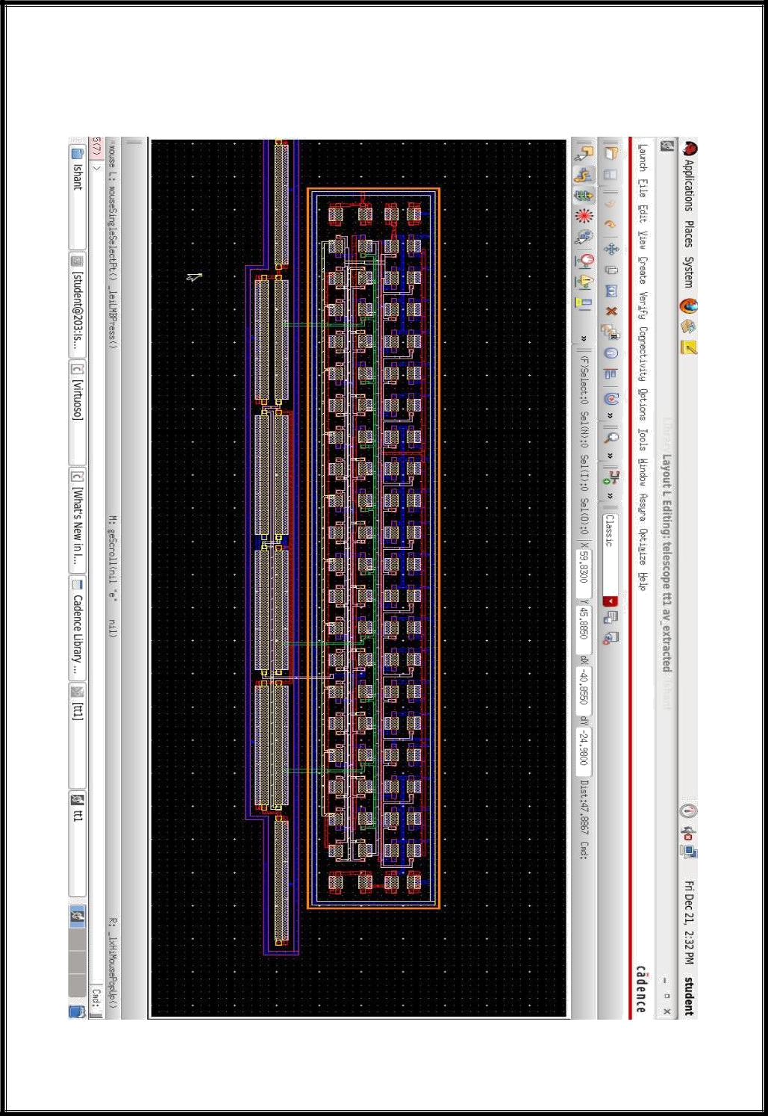

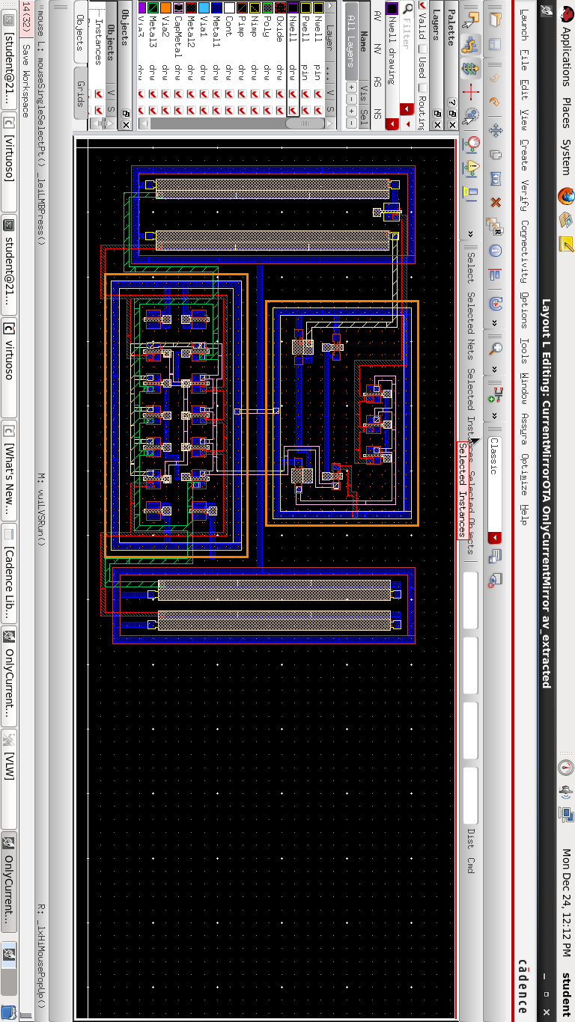

16 | P a g e
Post layout Simulation: The parasitic capacitance extracted according to how your layout is designed might be critical in affecting the actual performance of your design. In order to get an idea of how the design would work from your layout, you should perform a post-layout simulation from the extracted view. The procedure is identical to that for simulating from the schematic view.

RESULT:
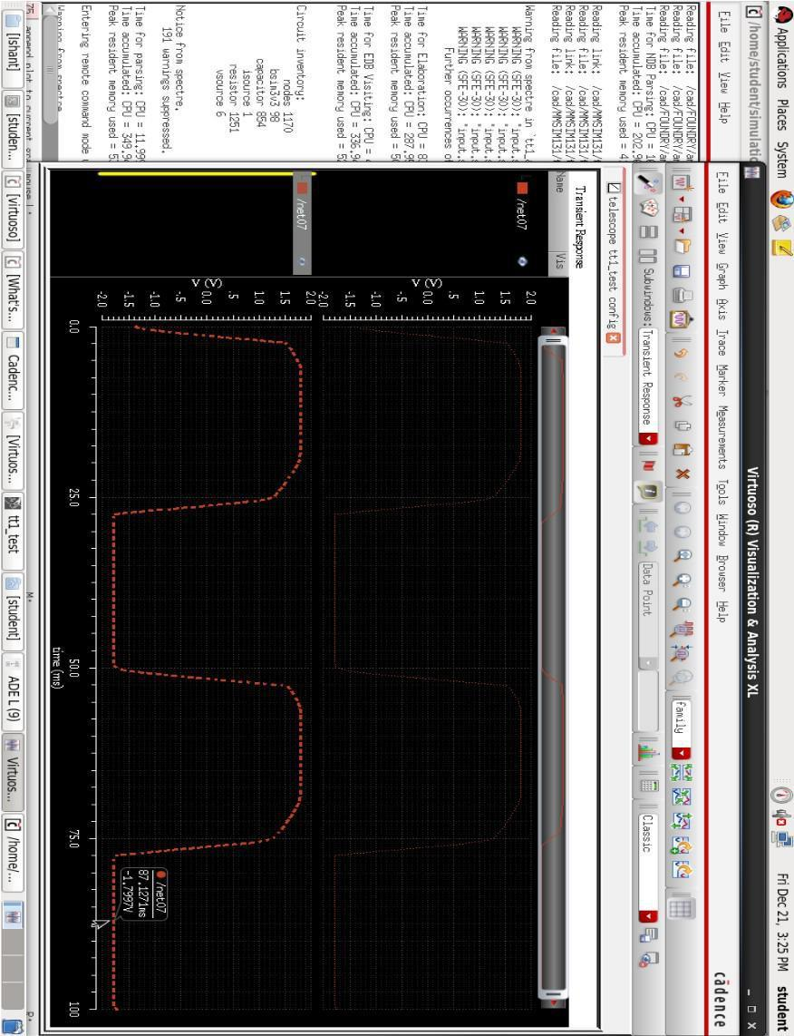

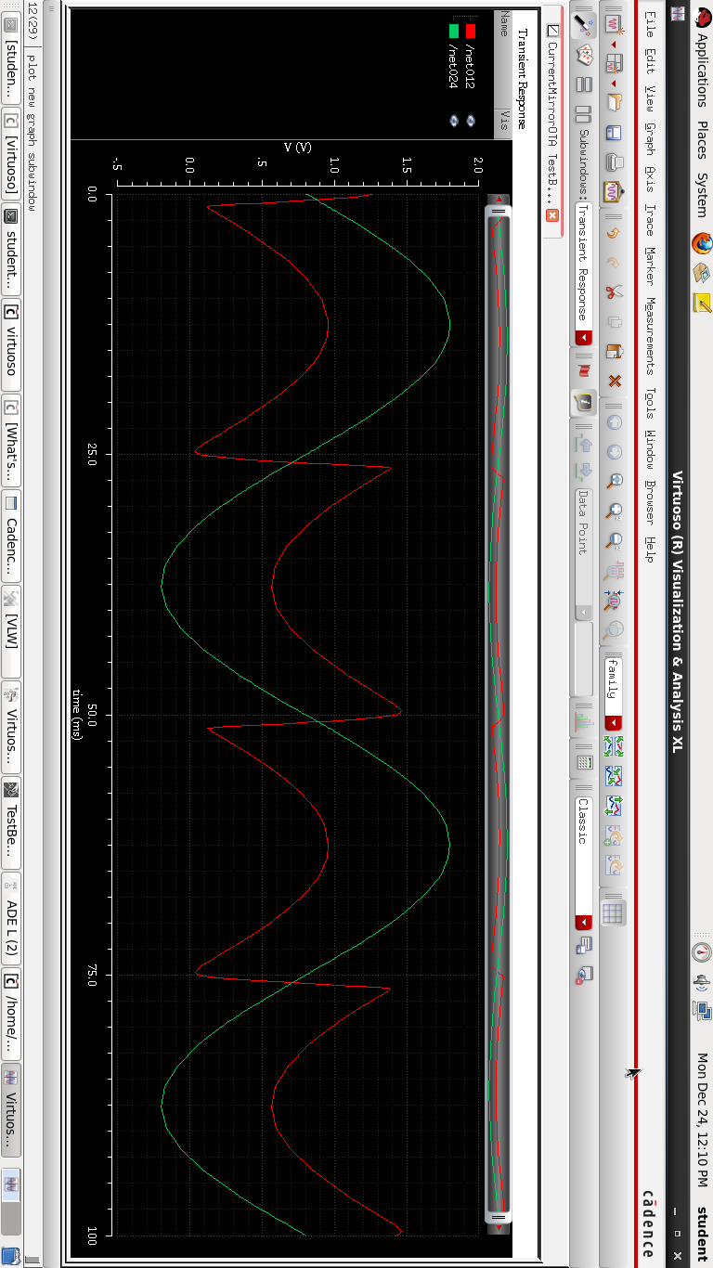

17 | P a g e
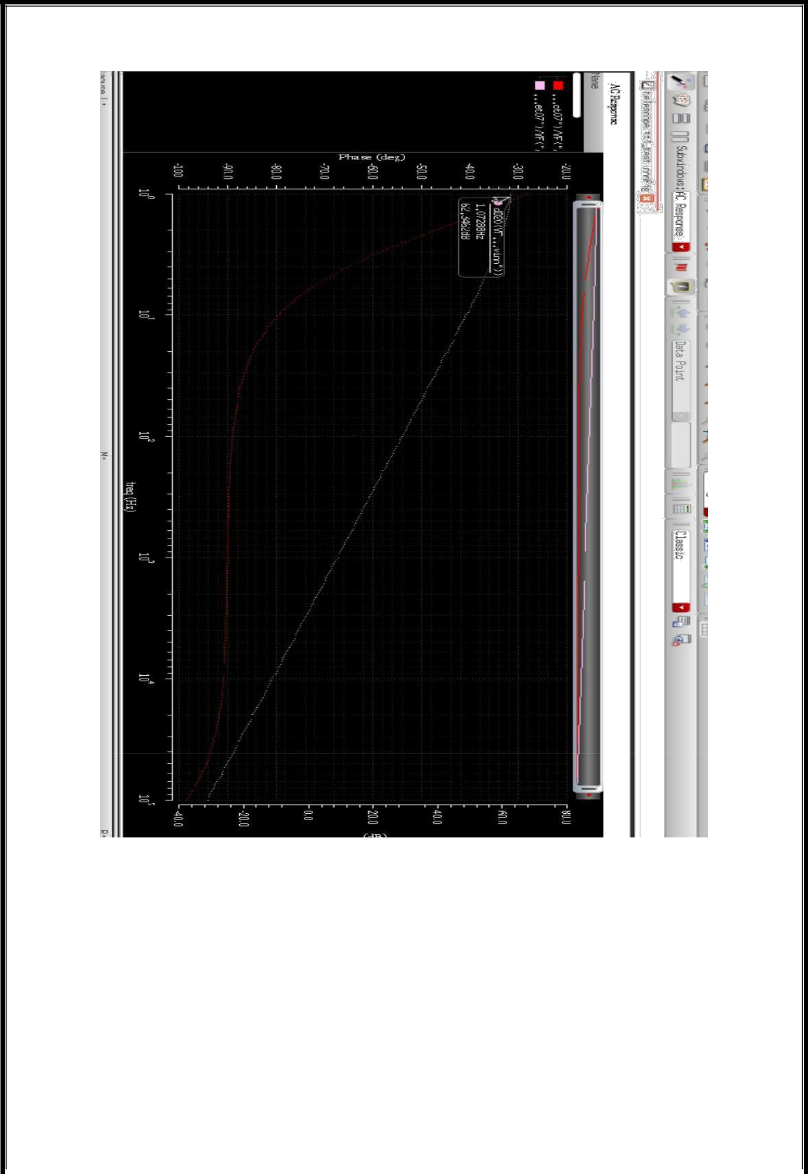
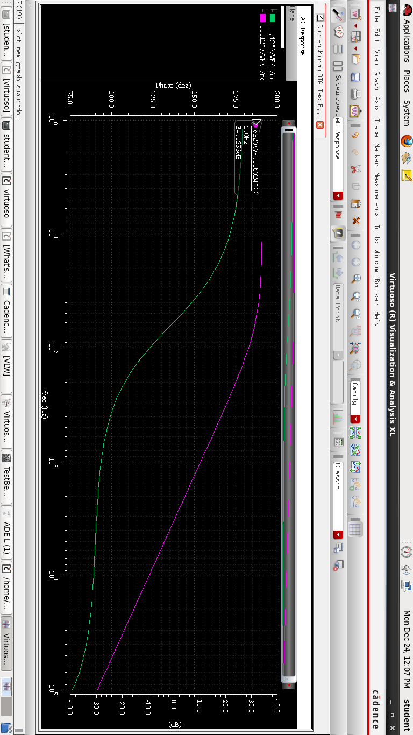

After Post layout simulation the Gain comes out to be 34 db. Also the gain of schematic simulation is 47 db.

18 | P a g e

Comparison of Results:

 | PRE-LAYOUT |  | POST-LAYOUT
 | SIMULATION |  | SIMULATION
GAIN | 47dB |  | 34dB
BSIN3/3 | 18 | 32
NODES | 17 |  | 335
CAPACITOR | 3 | 244
ISOURCE | 1 |  | 1
RESISTOR | - | 361
VSOURCE | 5 |  | 6

19 | P a g e
APPLICATIONS OF CURRENT MIRROR OTA

1) Current Mirror OTA for ultra-low power applications.

The PMOS transistor has lower ﬂicker noise than the NMOS transistor. This advantage makes the ampliﬁer with the PMOS input transistors a main choice for ultra-low-power and low frequency application.

2) In the field of Neuroscience.

The accelerating pace of research in neuroscience has created a considerable demand for neural interfacing microsystems capable of monitoring the activity of large groups of neurons. These emerging tools have revealed a tremendous potential for the advancement of knowledge in brain research and for the development of useful clinical applications. They can extract the relevant control signals directly from the brain enabling individuals with severe disabilities to communicate their intentions to other devices, like computers or various prostheses. Such microsystems are self-contained devices composed of a neural probe attached with an integrated circuit for extracting neural signals from multiple channels, and transferring the data outside the body. The greatest challenge facing development of such emerging devices into viable clinical systems involves addressing their small form factor and low-power consumption constraints, while providing superior resolution.

20 | P a g e

CONCLUSION

The main objective of this project is to propose a Current Mirror OTA for better gain, low noise and power. The design and experimental results of a current mirror OTA has been presented. The proposed current mirror OTA can achieve a maximum gain of 34 dB. Simulation results of the present work with reference to gain, power, input referred noise, CMRR and NEF have recommended that the proposed current mirror OTA is more suitable for low frequency bio signal applications such as EEGs also as a preamplifier in neural recordings.

21 | P a g e
REFERENCES

- https://www.edaboard.com/showthread.php?126059-What-are-the-advantages-of-current-mirror-OTA

- https://www.youtube.com/watch?v=AjKTnIHvuAI

- https://www.youtube.com/watch?v=V1lEVjhxdic

- https://ieeexplore.ieee.org/document/4100866

22 | P a g e

